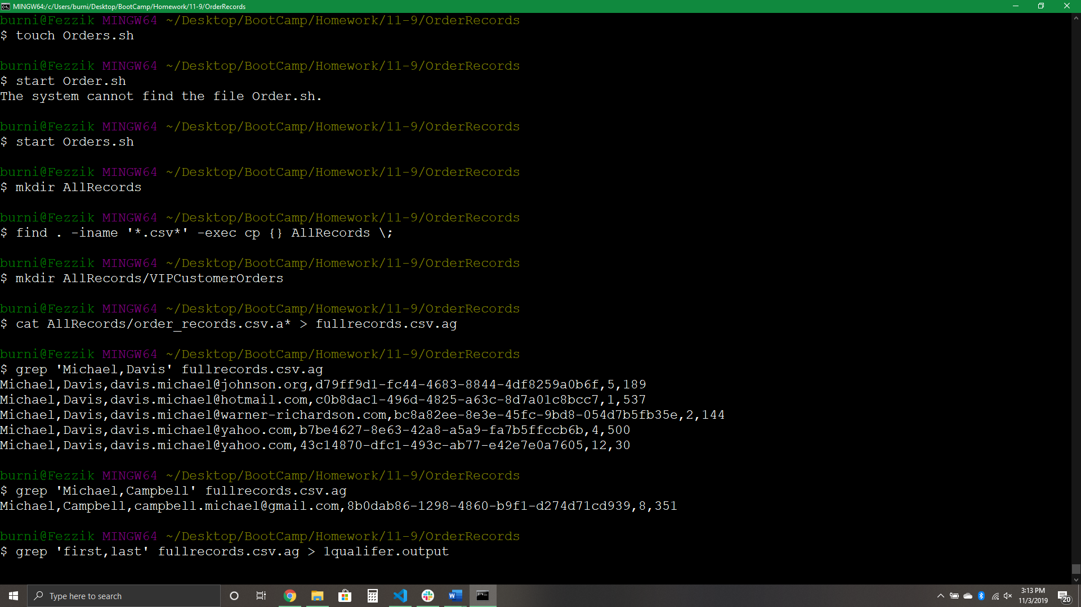

Grab the first CSV Entry to help clarify the entries and output to a new file

Display all Records of Michael,Campbell

Display all Records of Michael,Davis

Create New Directory VIPCustomerOrders

Put the contents of all the records into a single workable file

Find all .csv’s and copy to AllRecords

Create New Directory AllRecords

Open the Script

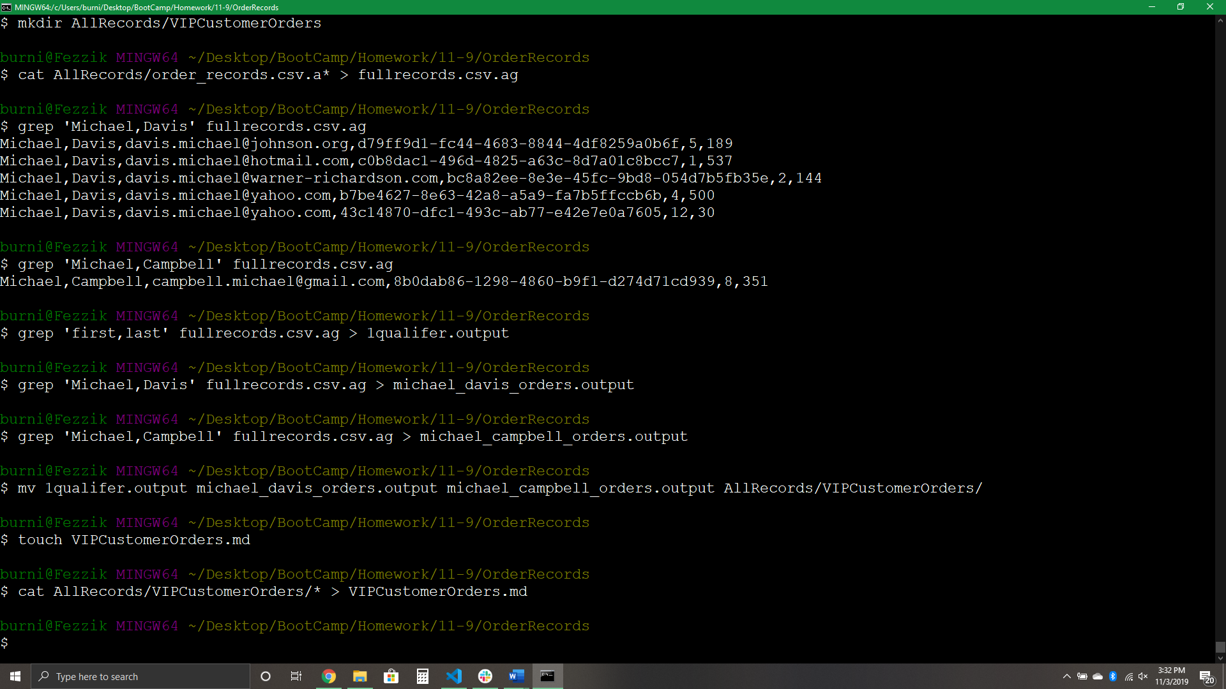

You can see this part on the first page so I put a text box here to avoid confusion

Put the contents of all the records in the directoy into a single workable file

Make a new file called VIPCustomerOrders.md

Move the three new files into the VIPCustomerOrders

Grab Michael Campbell ‘s data and output to a new file

Grab Michael Davis ‘s data and output to a new file

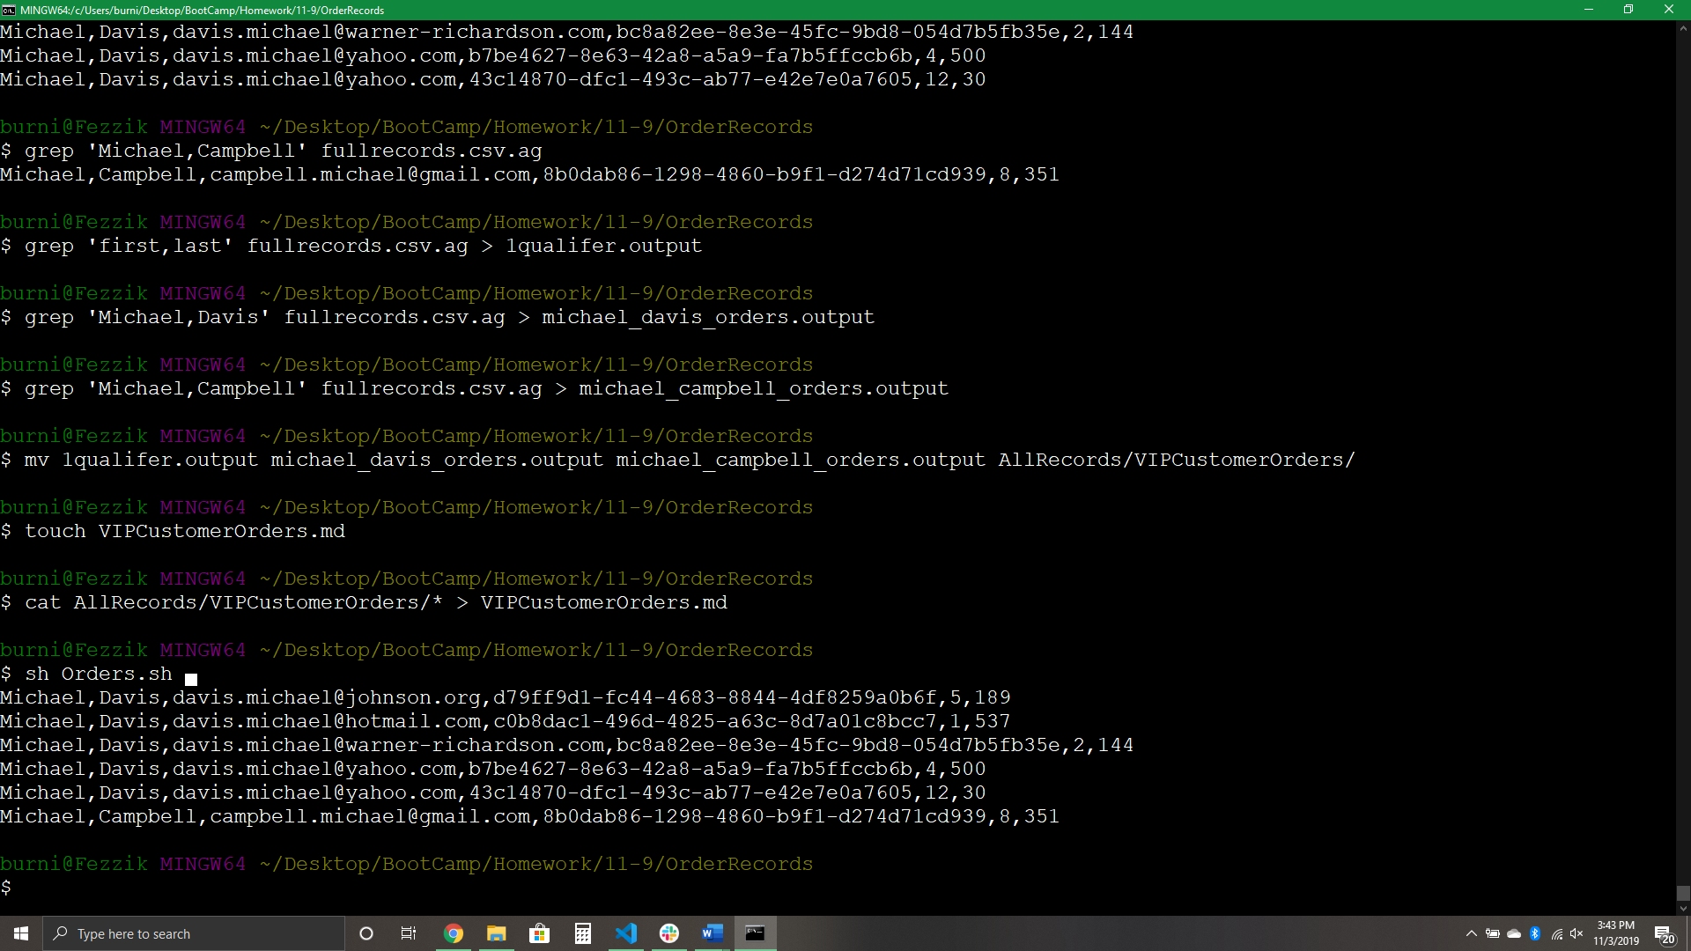

Starting the Orders.sh Script

You can see this part on the second page so I put a text box here to avoid confusion

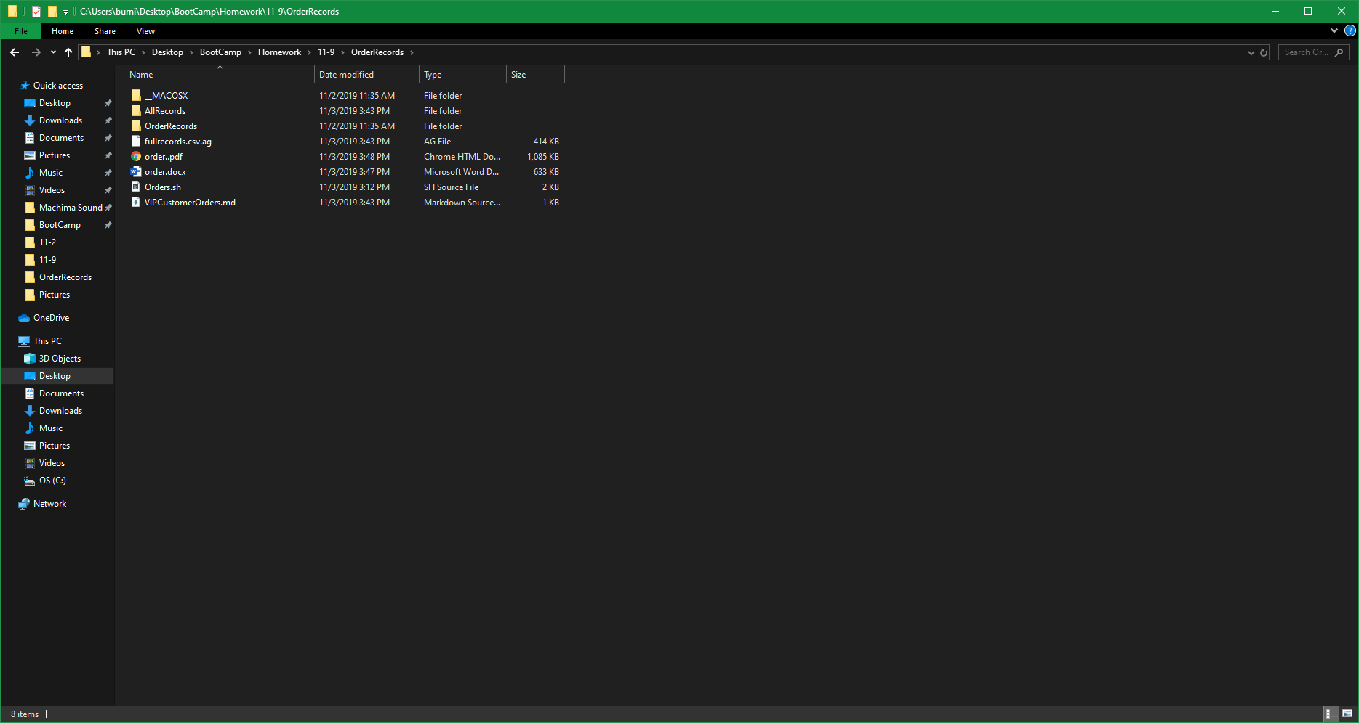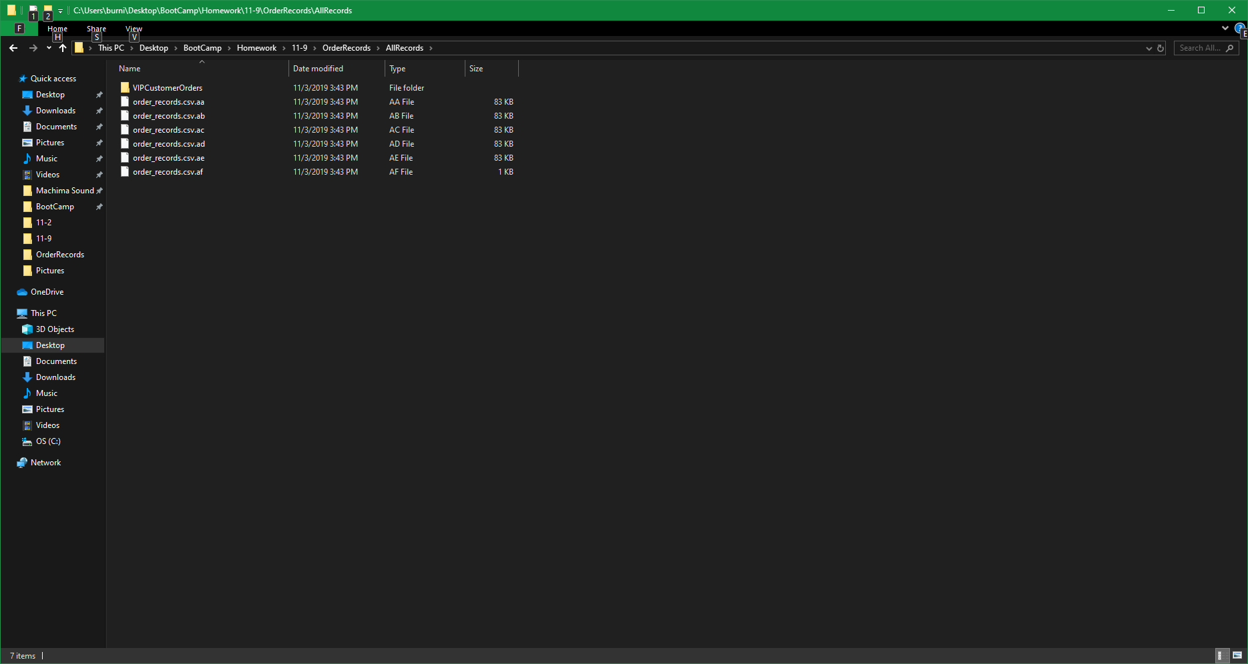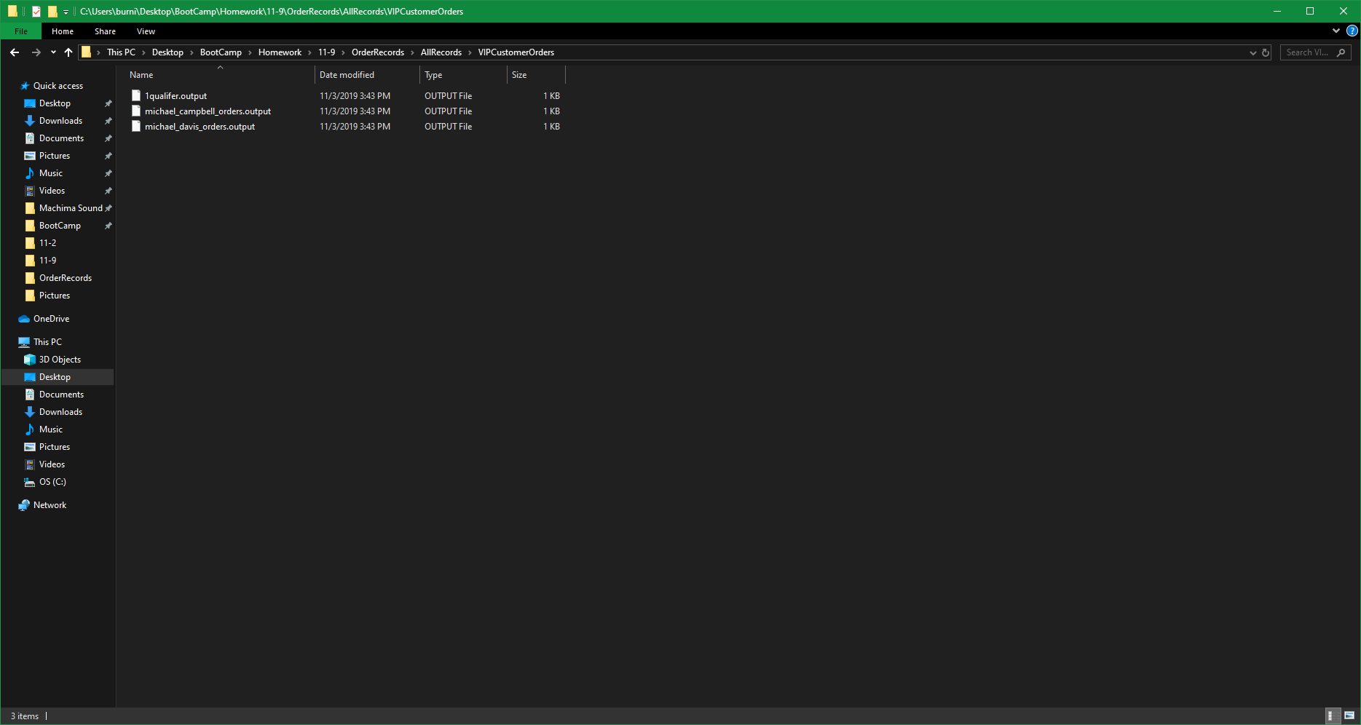

My Directory after running the script

All the records in one folder

All the VIP Outputs in one folder